# CHAPTER 1 INTRODUCTION

## 1.1 OVERVIEW OF THE PROJECT

“Online Bus Information System” is the web based application that provides an efficient way to maintain various information and generate the reports. The ticket booking information are immediately stored in the respective database. The view ticket is available for passengers and it can be downloaded in the PDF format.

Before booking the ticket, the respective user must login to the web application, which is requested by the administrator. The request approval has been done through web application. The booked tickets can be cancelled three days in prior. This can be done by clicking the cancel button in view ticket form. The ticket cancelling information is immediately updated in the database.

In this project, the requirement is to build a web application to manage fleet details by administrator. In the process of fleet management, the owners have full control of the maintenance of a vehicle fleet. It can be used to record almost every aspect of fleet maintenance activities.

The software is enhanced by using the report generation tool which is embedded in the web application. This feature helps the supervisor of company and admin to have the better bus quality enhancements. The generated reports can be downloaded for later use.

In current growing market, it is mandatory for cost benefit management to give option for administrator to manage profit or loss. This profit or loss is calculated for the given period of time.

# CHAPTER 2

**SYSTEM ANALYSIS**

## EXISTING SYSTEM

Existing system allows visitors to check bus ticket availability, buy bus ticket and pay the amount for bus ticket through online. The bus transportation system, provides facility to reserve seats, cancel seats and different types of enquiry can be made which needs an instant and quick response.

Existing system deals with maintenance of records of each passenger who have reserved a seat for a journey. It also includes maintenance of information like schedule and details of each bus. The details of the crew management like fuel record, accident record, maintenance record are maintained in the excel workbook. The profit and loss analysis of the system is done manually.

## Drawbacks of the existing system

* + - Fleet management is not maintained.
    - Cost benefit analysis is done manually.
    - Manual calculation is error prone.
    - Imports and Exports of records to different required format is not available.
    - No direct role for the higher officials.

To avoid all these limitations and make the working more accurately the system needs to be enhanced.

## PROPOSED SYSTEM

The aim of proposed system is to develop a system of improved facilities. The proposed system can overcome all the limitations of the existing system. The system allows visitors check bus ticket availability, buy bus ticket and pay the bus ticket online. This system provides crew management which maintains the fuel records, accident records, maintenance records.

This system provides fleet management which maintains the details of stock, rebuild tyres, repairs and insurance. The fleet maintenance records will have their costs attached to them so that the users can generate various maintenance cost reports.

The system provides graphical charts for fuel consumption and maintenance expenses. Here data can be imported into any table from an excel file or csv file and the system can also export data into excel file, csv file, word file, pdf file. This system provides cost benefit analysis to track the profit or loss of the system.

## Advantages of proposed system

The system is very simple in design and to implement. The system requires very low system resources and the system will work in almost all configurations. It has got following features

* + - Fleet management is done effectively.
    - Cost benefit analysis is computerized.
    - Imports and exports of records to different required format is available.
    - Graphical chart is embedded for analysis.

## FEASIBILITY STUDY

During system analysis, the feasibility study of the proposed system is to be carried out. This is to ensure that the proposed system is not a burden to the user. For feasibility analysis, some understanding of the major requirements of the system is essential. Three key considerations involved in the feasibility analysis are

* + - Technical Feasibility
    - Operational Feasibility
    - Economical Feasibility

## Technical Feasibility

The technical feasibility basically centers on alternatives for hardware, software and design approach to determine the functional aspects of system. This web application will be useful for mobile and web users because it is being enhanced with Bootstrap.

.

## Operational Feasibility

Operational feasibility is the measure of how well a proposed system solves the problems in the existing system. Embedding the report generation features, graphical chart and import and export of data with this web application makes it easier to generate report from any device and supervisor of system need not to use a separate tool for report generation and integrating the generated reports with the web application has been reduced.

## Economical Feasibility

Embedding the report generating features with this web application makes it easier to generate report from any device and editor need not to use a separate tool for report generation and integrating the generated reports with the web application has been reduced. Hence no

need to buy the additional software tool to install on supervisor device for the report generation and maintenance cost of additional software tool also reduced.

## PROBLEM ANALYSIS

The first step in the software development life cycle is the identification of the problem as the success of the system depends on how accurately a problem is identified. At present, the fleet maintenance records are stored using Excel workbook.

The consolidated revenue reports such as fleet report, fuel report, maintenance report, stock movement report, stock balance report, accident report and analysis reports such as cost benefit report, fuel consumption chart and maintenance expenses chart are tedious to generate. To overcome this problem, the software is required and it should be capable of managing the transactions in network environment.

This system provides crew management which maintains the fuel records, accident records, maintenance records. In crew management, graphical chart is generated for fuel consumption which is used to analysis the fuel record for the separate bus and the certain period of days. The maintenance expenses can be easily analyzed by using the graphical charts..

This system provides fleet management which maintains the stock management, rebuild tyres, repairs, insurance management. The fleet maintenance records will have their costs attached to them so that the users can generate various maintenance cost reports.

If you have imported excel file or pasted csv data, you will get to screen with options to map the fields. It is advisable that import rights are given only to admin users since it may cause incorrect/duplicate data if wrong data is imported.

The software used to solve the problem and develop the application with CodeIgniter PHP programming using sublime with Doctrine ORM and Mysql.

## DATA FLOW DIAGRAM

The data flow diagram shows the overview of the entire system as a series of process and it shows the interaction between the system and the external agents. The process are bus ticket reservation, crew management, fleet management and cost benefit analysis.

## CONTEXT DIAGRAM

The context diagram shows the overview of the entire system as a single process and it shows the interaction between the system and the external agents. The stack holders are admin, supervisor and user.

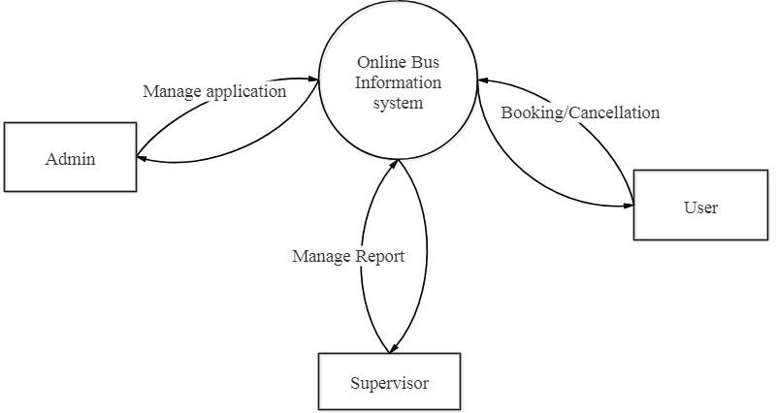

Figure 2.1 Context diagram for Online Bus Information System

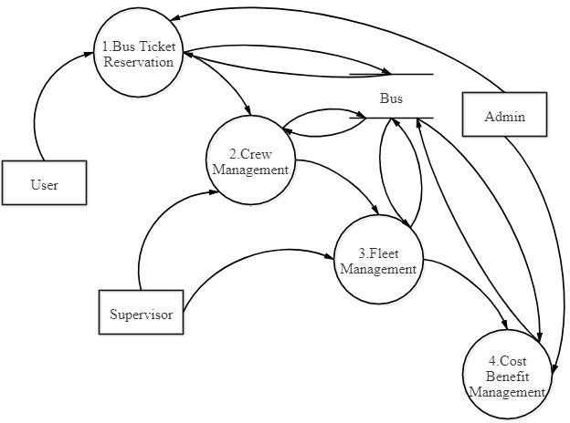

Figure 2.2 Level 1 DFD for Online Bus Information System

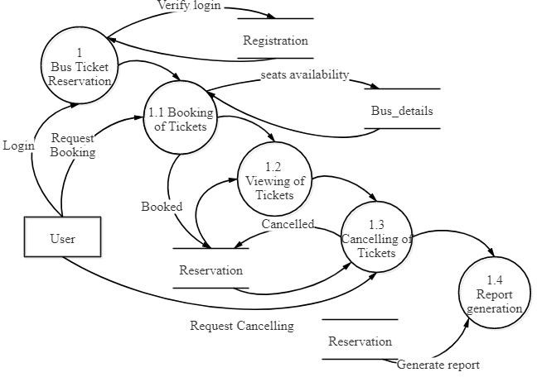

Figure 2.3 Level 2 DFD for Bus Ticket Reservation

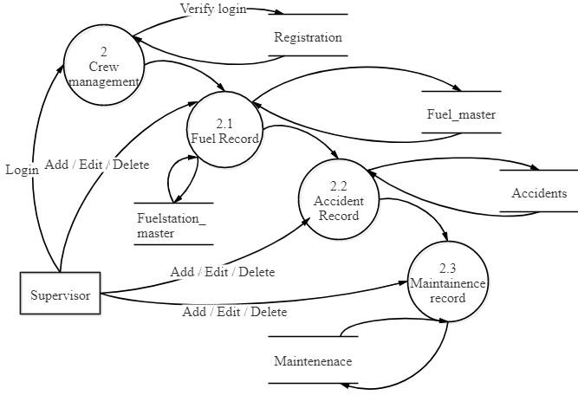

Figure 2.4 Level 2 DFD for Crew Management

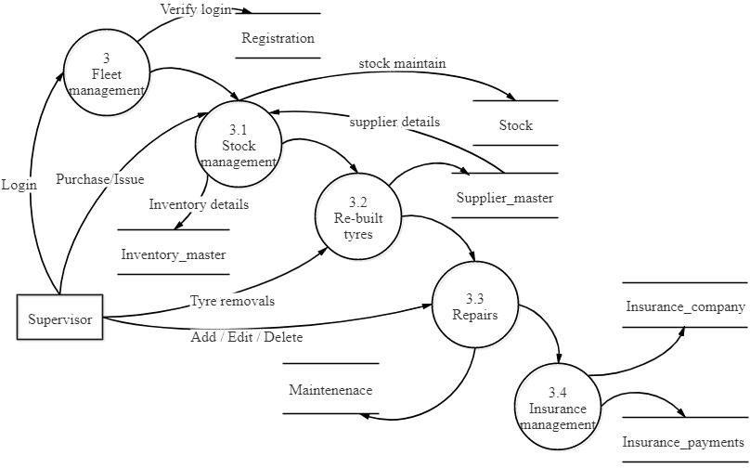

Figure 2.5 Level 2 DFD for Fleet management

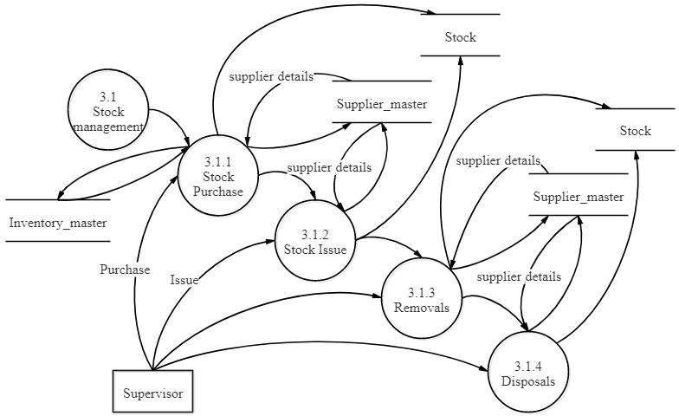

Figure 2.6 Level 3 DFD for Stock management

## SYSTEM SPECIFICATION

* + 1. **Hardware Specification**

This section gives the details and specification of the hardware on which the system is expected to work.

Processor : Pentium core processor

RAM : 2 GB RAM

Hard Disk : 20 GB storage

Monitor : 17” Color

System type : 64-bit operating system

## Software Specification

This section gives the details and specification of the software on which the system is expected to work.

Operating System : Windows 7

Environment : Sublime

Scripting language : HTML5, JavaScript, JQuery,CSS3,PHP

PHP Framework : CodeIgniter 3.0

Backend : Mysql

## SOFTWARE DESCRIPTION

**Sublime**

Sublime Text is a proprietary cross-platform source code editor with a Python application programming interface (API). It natively supports many programming languages and markup languages, and functions can be added by users with plugins, typically community-built and maintained under free-software licenses.

## Bootstrap

Bootstrap is a [free and open source](https://en.wikipedia.org/wiki/Free_and_open-source_software) front-end [web framework](https://en.wikipedia.org/wiki/Web_framework) for designing [websites](https://en.wikipedia.org/wiki/Website) and [web applications.](https://en.wikipedia.org/wiki/Web_application) It contains [HTML](https://en.wikipedia.org/wiki/HTML)- and [CSS](https://en.wikipedia.org/wiki/CSS)-based design templates for [typography,](https://en.wikipedia.org/wiki/Typography) forms, buttons, navigation and other interface components, as well as optional [JavaScript](https://en.wikipedia.org/wiki/JavaScript) extensions. Unlike many web frameworks, it concerns itself with [front-end](https://en.wikipedia.org/wiki/Front-end_web_development) [development](https://en.wikipedia.org/wiki/Front-end_web_development) only.

## HTML

Hypertext Markup Language (HTML) is the standard [markup language](https://en.wikipedia.org/wiki/Markup_language) for creating [web pages](https://en.wikipedia.org/wiki/Web_page) and [web applications.](https://en.wikipedia.org/wiki/Web_application) With [Cascading Style Sheets](https://en.wikipedia.org/wiki/Cascading_Style_Sheets) (CSS) and [JavaScript](https://en.wikipedia.org/wiki/JavaScript) it forms a triad of cornerstone technologies for the [World Wide Web.](https://en.wikipedia.org/wiki/World_Wide_Web) [Web](https://en.wikipedia.org/wiki/Web_browser) [browsers](https://en.wikipedia.org/wiki/Web_browser) receive HTML documents from a [web server](https://en.wikipedia.org/wiki/Web_server) or from local storage and render them into multimedia web pages. HTML describes the structure of a web page [semantically](https://en.wikipedia.org/wiki/Semantic_Web) and originally included cues for the appearance of the document.

## CSS

Cascading Style Sheets (CSS) is a [style sheet language](https://en.wikipedia.org/wiki/Style_sheet_language) used for describing the [presentation](https://en.wikipedia.org/wiki/Presentation_semantics) of a document written in a [markup language.](https://en.wikipedia.org/wiki/Markup_language) Although most often used to set the visual style of [web pages](https://en.wikipedia.org/wiki/Web_page) and user interfaces written in [HTML](https://en.wikipedia.org/wiki/HTML) and [XHTML,](https://en.wikipedia.org/wiki/XHTML) the language

can be applied to any [XML](https://en.wikipedia.org/wiki/XML) document, including [plain XML,](https://en.wikipedia.org/wiki/Plain_Old_XML) [SVG](https://en.wikipedia.org/wiki/Scalable_Vector_Graphics) and [XUL,](https://en.wikipedia.org/wiki/XUL) and is applicable to rendering in [speech,](https://en.wikipedia.org/wiki/Speech_synthesis) or on other media.

**JavaScript**

JavaScript often abbreviated as JS, is a [high-level,](https://en.wikipedia.org/wiki/High-level_programming_language) [dynamic,](https://en.wikipedia.org/wiki/Dynamic_programming_language) [weakly typed,](https://en.wikipedia.org/wiki/Weak_typing) [prototype-](https://en.wikipedia.org/wiki/Prototype-based_programming) [based,](https://en.wikipedia.org/wiki/Prototype-based_programming) [multi-paradigm,](https://en.wikipedia.org/wiki/Multi-paradigm_programming_language) and [interpreted](https://en.wikipedia.org/wiki/Interpreted_language) [programming language.](https://en.wikipedia.org/wiki/Programming_language) Alongside [HTML](https://en.wikipedia.org/wiki/HTML) and [CSS](https://en.wikipedia.org/wiki/CSS), JavaScript is one of the three core technologies of [World Wide Web](https://en.wikipedia.org/wiki/World_Wide_Web) [content production.](https://en.wikipedia.org/wiki/Content_engineering) It is used to make webpages interactive and provide online programs, including video games. The majority of [websites](https://en.wikipedia.org/wiki/Website) employ it, and all modern [web browsers](https://en.wikipedia.org/wiki/Web_browser) support it without the need for [plug-ins](https://en.wikipedia.org/wiki/Browser_extension) by means of a built-in [JavaScript engine.](https://en.wikipedia.org/wiki/JavaScript_engine) Each of the many JavaScript engines represent a different implementation of JavaScript, all based on the [ECMAScript](https://en.wikipedia.org/wiki/ECMAScript) specification, with some engines not supporting the spec fully, and with many engines supporting additional features beyond ECMA.

**jQuery**

jQuery is a [cross-platform](https://en.wikipedia.org/wiki/Cross-platform) [JavaScript library](https://en.wikipedia.org/wiki/JavaScript_library) designed to simplify the [client-side](https://en.wikipedia.org/wiki/Client-side_scripting) [scripting](https://en.wikipedia.org/wiki/Client-side_scripting) of [HTML](https://en.wikipedia.org/wiki/HTML). It is [free, open-source software](https://en.wikipedia.org/wiki/Free_and_open_source_software) using the permissive [MIT License.](https://en.wikipedia.org/wiki/MIT_License) [Web](https://en.wikipedia.org/wiki/World_Wide_Web) analysis indicates that it is the most widely deployed JavaScript library by a large margin. jQuery's syntax is designed to make it easier to navigate a document, select [DOM](https://en.wikipedia.org/wiki/Document_Object_Model) elements, create [animations,](https://en.wikipedia.org/wiki/Animation) handle [events,](https://en.wikipedia.org/wiki/Event_(computing)) and develop [Ajax](https://en.wikipedia.org/wiki/Ajax_(programming)) applications.

**JSON**

JavaScript Object Notation is an [open-standard](https://en.wikipedia.org/wiki/Open_standard) [file format](https://en.wikipedia.org/wiki/File_format) that uses [human-readable](https://en.wikipedia.org/wiki/Human-readable_medium)text to transmit data objects consisting of [attribute–value pairs](https://en.wikipedia.org/wiki/Attribute%E2%80%93value_pair) and [array data types](https://en.wikipedia.org/wiki/Array_data_type) (or any other [serializable](https://en.wikipedia.org/wiki/Serialization) value). It is a very common data format used for [asynchronous](https://en.wikipedia.org/wiki/Asynchronous_I/O) browser–server communication, including as a replacement for [XML](https://en.wikipedia.org/wiki/XML) in some [AJAX](https://en.wikipedia.org/wiki/Ajax_(programming))-style systems.

JSON is a [language-independent](https://en.wikipedia.org/wiki/Language-independent_specification) data format. It was derived from [JavaScript](https://en.wikipedia.org/wiki/JavaScript), but as of 2017 many [programming languages](https://en.wikipedia.org/wiki/Programming_language) include code to generate and [parse](https://en.wikipedia.org/wiki/Parsing) JSON-format data. The official Internet [media type](https://en.wikipedia.org/wiki/Media_type) for JSON is application/json . JSON filenames use the extension .json .

## MVC

The Model-View-Controller (MVC) is an architectural pattern that separates an application into three main logical components such as the model, the view, and the controller.

**PHP**

The PHP Hypertext Preprocessor (PHP) is a programming language that allows web developers to create dynamic content that interacts with databases. PHP is basically used for developing web based software applications. PHP has received criticism due to lacking native [unicode](https://en.wikipedia.org/wiki/Unicode) support at the core language level, instead only supporting byte strings.

## CodeIgniter Framework

CodeIgniter is an application development framework, which can be used to develop websites, using PHP. It is an Open Source framework. It has a very rich set of functionality, which will increase the speed of website development work. Some of the features are

* + - Model-View-Controller Based System
    - Extremely Light Weight
    - Full Featured database classes with support for several platforms.
    - Query Builder Database Support

## MySql

MySql is a freely available open source Relational Database Management System (RDBMS) that uses Structured Query Language (SQL). SQL is the most popular language for adding, accessing and managing content in a database.

## ORM

Object-relational mapping (ORM, O/RM, and O/R mapping tool) is a programming technique for converting data between incompatible type systems using object-oriented programming languages. In effect, this creates a "virtual object database" that can be used from within the programming language.

# CHAPTER 3 SYSTEM DESIGN

## INPUT DESIGN

Input design is the process of converting user originated inputs to a computer understandable format. Input design is one of the most expensive part of the operation of computerized system. Input data are collected and organized into groups of similar data. Every moment of input design should be analyzed and designed with most care.

The main objective of input design is

* + - To process the clear requirements
    - To get highest level of accuracy
    - To produce desired output
    - Data recording
    - Data verification

The input design involves converting user originated inputs into a sub system based format. The aim of input design is to make the data entry easier, logical error free. The following forms are included in this input form.

## Registration form

Any user can register in the web application in order to book the ticket. Supervisor can be added to the system only if the admin approve the request.

## Search ticket

The search ticket form get details like source station, destination station, journey date, number of passenger, bus type. Those details are entered in textboxes.

## Booking ticket

The booking ticket form get details like name of the passenger, age of the passenger and the sex of the passenger. Those details are entered in textboxes. These details are stored in reservation table.

## Cancellation ticket

The cancellation ticket form get ticket number as the only input. This detail is entered in textbox. This detail changes the field status to cancel in reservation table.

## Add bus

The add bus form get details like bus number, coach type, source station, destination station, start time, reach time, number of seats and fare. These details are entered using textboxes and combo box. These details are stored in bus table.

## Fuel form

The fuel form get details like fleet, vehicle, coupon, fuel date, fuel station, meter reading, litre pumped, litre.price, fill type, last mileage and system date. These details are entered using textboxes and combo box. These details are stored in fuelreport table. In this fields the meter reading should be greater than the last mileage.

## Accidents form

The accident form get details like fleet, vehicle, type, date, time, location, driver, deaths, injured, description, vehicle damage, 3rd party damages and system date. These details are entered using textboxes and combo box. These details are stored in accident table. In this

date is entered using datepicker and the time is entered using timepicker. Some of the values of fields assigned in default.

## DATABASE DESIGN

The most important consideration in designing the database is how the information will be used. The main objective of designing a database is:

## Data Integration

In a database, information from several files are coordinated, accessed and operated upon as through it is in a single file. Logically, the information are centralized, physically, the data may be located on different devices, connected through data communication facilities.

## Data Integrity

Data integrity means storing all data in one place only and how each application access it. This approach results in more consistent information, one update being sufficient to achieve a new record status for all applications. This leads to less data redundancy: data items need not be duplicated: a reduction in the direct access storage requirement.

## Data Independence

Data independence is the insulation of application programs from changing aspects of physical data organization. This objective seeks to allow changes in the content and organization of physical data without reprogramming of application and to allow modifications to application programs without reorganizing the physical data. The tables needed for each module were designed and the specification of each and every column was given based on the records and the details collected during record specifications of the system study.

## TABLE DESIGN

**Table 3.1 Registration**

|  |  |  |  |
| --- | --- | --- | --- |
| **FIELD NAME** | **FIELD TYPE** | **SIZE** | **CONSTRAINT** |
| Id | Int | 11 | Not null |
| Username | Varchar | 30 | Primary key |
| Password | Varchar | 30 | Not null |
| Firstname | Varchar | 30 | Not null |
| Lastname | Varchar | 30 | Not null |
| Sex | Varchar | 6 | Not null |
| Phonenumber | Varchar | 10 | Not null |
| Email_id | Varchar | 30 | Not null |

**Table 3.2 Bus Details**

|  |  |  |  |
| --- | --- | --- | --- |
| **FIELD NAME** | **FIELD TYPE** | **SIZE** | **CONSTRAINT** |
| Serviceno | Int | 4 | Primary key |
| Busname | Varchar | 30 | Not null |
| Bustype | Varchar | 30 | Not null |
| Source | Varchar | 30 | Not null |
| Destination | Varchar | 30 | Not null |
| Start_time | Time | - | Not null |
| Reach_time | Time | - | Not null |
| Avail | Int | 3 | Not null |
| Status | Varchar | 15 | Not null |
| Fare | Int | 6 | Not null |

**Table 3.3 Reservation**

|  |  |  |  |
| --- | --- | --- | --- |
| **FIELD NAME** | **FIELD TYPE** | **SIZE** | **CONSTRAINT** |
| Id | Int | 4 | Primary key |
| Serviceno | Int | 4 | Foreign key |
| Username | Varchar | 20 | Foreign key |
| Pass_name | Varchar | 20 | Not null |
| Age | Int | 2 | Not null |
| Sex | Varchar | 6 | Not null |
| Seat | Int | 3 | Not null |
| Flag | Int | 7 | Not null |
| Book_date | Date | - | Not null |
| Dep_date | Date | - | Not null |
| Cancel_date | Date | - | Null |

**Table 3.4 Accidents**

|  |  |  |  |
| --- | --- | --- | --- |
| **FIELD NAME** | **FIELD TYPE** | **SIZE** | **CONSTRAINT** |
| Id | Int | 4 | Primary key |
| Sysdate | Date | - | Not null |
| Date | Date | - | Not null |
| Time | Time | - | Not null |
| Fleet | Varchar | 10 | Not null |
| Serviceno | Int | 4 | Foreign key |
| Type | Varchar | 20 | Not null |
| Details | Varchar | 200 | Not null |
| Driver | Varchar | 15 | Not null |
| Injured | Varchar | 40 | Not null |
| Deaths | Varchar | 40 | Not null |
| Damage to vehicle | Varchar | 40 | Not null |
| 3rdpartydamages | Varchar | 40 | Not null |
| Images | Varchar | 200 | Not null |
| Location | Varchar | 20 | Not null |

**Table 3.5 Stock Details**

|  |  |  |  |
| --- | --- | --- | --- |
| **FIELD NAME** | **FIELD TYPE** | **SIZE** | **CONSTRAINT** |
| Id | Int | 11 | Primary key |
| Itemcode | Varchar | 40 | Null |
| Brand | Varchar | 40 | Null |
| Description | Varchar | 40 | Null |
| Supplier | Varchar | 40 | Null |
| Quantity | Varchar | 40 | Null |
| Removedfrom | Varchar | 4 | Null |
| Systemdate | Date | - | Null |
| Grndate | Date | - | Null |
| Enteredby | Varchar | 40 | Null |
| Approvedby | Varchar | 40 | Null |
| Unitprice | Int | 10 | Null |
| Status | Varchar | 40 | Null |
| Refnumber | Varchar | 40 | Null |
| Currentstock | Varchar | 15 | Null |
| Fleet | Varchar | 40 | Null |
| Cost | Int | 40 | Null |

**Table 3.6 Fleet Type**

|  |  |  |  |
| --- | --- | --- | --- |
| **FIELD NAME** | **FIELD TYPE** | **SIZE** | **CONSTRAINT** |
| Id | Int | 11 | Primary Key |
| Fleettype | Varchar | 40 | Null |
| Incharge | Varchar | 40 | Null |

**Table 3.7 Fuel Master**

|  |  |  |  |
| --- | --- | --- | --- |
| **FIELD NAME** | **FIELD TYPE** | **SIZE** | **CONSTRAINT** |
| Id | Int | 11 | Primary Key |
| Systemdate | Date | - | Null |
| Fueldate | Date | - | Null |
| Serviceno | Int | 4 | Foreign key |
| Meterreading | Int | 20 | Null |
| Literspumped | Int | 10 | Null |
| Priceperliter | Int | 10 | Null |
| Fuelstation | Varchar | 40 | Foreign Key |
| Fleet | Varchar | 40 | Null |
| Lastmileage | Int | 20 | Null |
| Economy | Int | 15 | Null |
| Filltype | Varchar | 15 | Null |
| Driver | Varchar | 40 | Null |

**Table 3.8 Fuel Station Master**

|  |  |  |  |
| --- | --- | --- | --- |
| **FIELD NAME** | **FIELD TYPE** | **SIZE** | **CONSTRAINT** |
| Id | Int | 11 | Not Null |
| Fuelstation | Varchar | 40 | Primary Key |
| Address | Varchar | 60 | Null |
| Contactnumber | Varchar | 10 | Null |
| Deposit | Varchar | 40 | Null |

**Table 3.9 Insurance Claims**

|  |  |  |  |
| --- | --- | --- | --- |
| **FIELD NAME** | **FIELD TYPE** | **SIZE** | **CONSTRAINT** |
| Id | Int | 11 | Primary key |
| Sysdate | Date | - | Null |
| Fleet | Varchar | 20 | Null |
| Type | Varchar | 20 | Null |
| Serviceno | Int | 4 | Foreign key |
| Accidentdate | Date | - | Null |
| Claim | Varchar | 10 | Null |
| Enteredby | Varchar | 25 | Null |
| Receiptno | Varchar | 10 | Null |
| Insurer | Varchar | 40 | Null |

**Table 3.10 Insurance Company**

|  |  |  |  |
| --- | --- | --- | --- |
| **FIELD NAME** | **FIELD TYPE** | **SIZE** | **CONSTRAINT** |
| Id | Int | 11 | Not null |
| Name | Varchar | 20 | Primary key |
| Address | Varchar | 40 | Null |
| Contactname | Varchar | 20 | Null |
| Contactnumber | Varchar | 10 | Null |

**Table 3.11 Inventory Master**

|  |  |  |  |
| --- | --- | --- | --- |
| **FIELD NAME** | **FIELD TYPE** | **SIZE** | **CONSTRAINT** |
| Id | Int | 11 | Primary key |
| Itemid | Varchar | 10 | Null |
| Brand | Varchar | 20 | Null |
| Description | Varchar | 200 | Null |
| Supplier | Varchar | 40 | Null |

**Table 3.12 Maintenance**

|  |  |  |  |
| --- | --- | --- | --- |
| **FIELD NAME** | **FIELD TYPE** | **SIZE** | **CONSTRAINT** |
| Id | Int | 11 | Primary key |
| Fleet | Varchar | 40 | Null |
| Serviceno | Int | 4 | Null |
| Type | Varchar | 20 | Null |
| Supplier | Varchar | 25 | Null |
| Cost | Int | 10 | Null |
| Remarks | Varchar | 150 | Null |
| Refno | Varchar | 10 | Null |
| Sysdate | Date | - | Null |
| Date | Date | - | Null |
| Enteredby | Varchar | 25 | Null |
| Approval | Varchar | 25 | Null |
| Meterreading | Int | 20 | Null |
| Accidentref | Varchar | 10 | Null |
| Paymentvoucher | Varchar | 20 | Null |
| Mainttype | Varchar | 10 | Null |

**Table 3.13 Supplier Master**

|  |  |  |  |
| --- | --- | --- | --- |
| **FIELD NAME** | **FIELD TYPE** | **SIZE** | **CONSTRAINT** |
| Id | Int | 11 | Primary key |
| Suppliername | Varchar | 40 | Null |
| Address | Varchar | 40 | Null |
| Contactperson | Varchar | 25 | Null |
| Telephone | Varchar | 10 | Null |

**Table 3.14 Other Renewal**

|  |  |  |  |
| --- | --- | --- | --- |
| **FIELD NAME** | **FIELD TYPE** | **SIZE** | **CONSTRAINT** |
| Id | Int | 11 | Primary key |
| Fleet | Varchar | 40 | Null |
| Serviceno | Int | 40 | Null |
| Vehicletype | Varchar | 40 | Null |
| Paymenttype | Varchar | 40 | Null |
| Paymentdate | Date | - | Null |
| Cost | Int | 40 | Null |
| Systemdate | Date | - | Null |
| Enteredby | Varchar | 40 | Null |
| Periodfrom | Date | - | Null |
| Periodto | Date | - | Null |
| Paymentref | Varchar | 40 | Null |

**Table 3.15 Vehicle Master**

|  |  |  |  |
| --- | --- | --- | --- |
| **FIELD NAME** | **FIELD TYPE** | **SIZE** | **CONSTRAINT** |
| Id | Int | 11 | Primary key |
| Regno | Varchar | 20 | Null |
| Fleet | Varchar | 20 | Null |
| Type | Varchar | 20 | Null |
| Regdate | Date | - | Null |
| Cost | Int | 40 | Null |
| Driverassigned | Varchar | 40 | Null |
| Make | Varchar | 20 | Null |
| Model | Varchar | - | Null |
| Insurancedue | Varchar | 15 | Null |

**Table 3.16 Admin Master**

|  |  |  |  |
| --- | --- | --- | --- |
| **FIELD NAME** | **FIELD TYPE** | **SIZE** | **CONSTRAINT** |
| Id | Int | 11 | Primary key |
| Username | Varchar | 40 | Null |
| Password | Varchar | 40 | Null |
| Email | Varchar | 40 | Null |
| Fullname | Varchar | 40 | Null |
| Groupid | Varchar | 40 | Null |

**Table 3.17 Analysis Master**

|  |  |  |  |
| --- | --- | --- | --- |
| **FIELD NAME** | **FIELD TYPE** | **SIZE** | **CONSTRAINT** |
| Id | Int | 11 | Primary key |
| From | Date | - | Null |
| To | Date | - | Null |
| Ticketcost | Int | 11 | Null |
| Fleetcost | Int | 11 | Null |
| Analysiscost | Int | 11 | Null |
| Profitlossstatus | Varchar | 10 | Null |

* 1. **MODULE DESIGN**

The main modules exists in this project are listed below

* + - Bus Ticket Reservation
    - Crew Management
    - Fleet Management
    - Cost Benefit Management

## Bus Ticket Reservation

The sub process in bus ticket reservation are

* + - * Book tickets.
      * View tickets.
      * Cancel tickets.
      * Report generation.

In the process of ticket booking the details of the passenger like one trip or two trip, source place, destination place, date of travelling, bus type are submitted to view the buslist. By selecting the bus the layout of the seats is viewed. The seats are chosen by the passenger and the personal details of the passengers like passenger name, age, sex are entered, then the pnr number is generated for the passenger. The ticket is displayed with the generated pnr number. The amount for the ticket is paid through paytm. The ticket can be downloaded as pdf format.

The next process is the viewing ticket. On providing the details of tickets like journey date, pnr number, service number(bus number), the details of the ticket like passenger_name, age, sex, seatno, journey_date are viewed.

In ticket cancellation process the button named cancel in viewing tickets is pressed, then the details of ticket is updated by changing in the field status from booked to cancelled. The fare of the ticket is refunded to the account based on date of cancellation. The report generation of the particular bus includes the passenger_name, seat_number, journey_date, age and sex of the passenger booked.

## Crew Management

The sub process in Crew management are

* + - * Fuel record
      * Accident record
      * Maintenance record

Fuel record enables users to keep track of all sort of refueling details. It will also show the fuel efficiency of the vehicles. Adding a fuel record is easy. Just select “Fuel Records” and then “Add new” button. Fuel Economy can be calculated from one full tank instance to another full tank instance only. Even if you are making a full tank, if your previous fill was a partial fill then the economy is not calculated. Further, Last mileage & driver name are automatically pulled from the database which can also be manually adjusted if you need in any case.

Accident record facilitates the recording of all accidents. Some of the details can be cross linked to other modules. For instance, accident repairs will have reference to the accident records. Accident records will have detailed information about the accident including casualties, damage to the own vehicle, damages to third parties, accident date, time, location, driver, etc. Further, you can attach a picture of the accident scene if any.

Maintenance record is for recording all the regular/periodic maintenance details of vehicles. All maintenance expenses other than repairs are recorded in the maintenance module. Types of maintenance expenses can be defined in the “Service Types”.

## Fleet management

The sub process in fleet management are

* + - * Stock management.
      * Rebuilt tyre management.
      * Repairs management.
      * Insurance details maintenance.

Stock management can be used to record and track all sorts of stock items used in fleet maintenance such as tyres, oils, bulbs, etc. Stock management has four segments as

* + - * **Stock purchases** – this will record all the purchases including quantity and cost.
      * **Stock issues** – this will record all the stock issued to vehicles. All issues will have a cost attached to it. This will enable users to generate the cost of stocks issued to a particular vehicle in reports.
      * **Removals –** this means the items removed from vehicles. For instance, if a head light is burnt, it will be removed from the vehicle and the item will get back into the inventory. Such items will bear zero cost.
      * **Disposals** – this means the disposal of stock items. Such items could be in good condition or ones which have been removed from vehicles.

Rebuild Tyres is used to record tyre rebuilding activities in case tyre rebuilding is done.

Entire process of tyre rebuilding is

* + - * **Tyre Removals** – i.e. removal from worn out tyres from vehicles which will be added back to the stock at zero cost.
      * **Sending to Rebuild** – i.e. sending the tyre rebuilding company from the stock.
      * **Rebuilt Receipts** – i.e. receiving the tyres after rebuilding into the stocks. Now the cost of the tyre will be the cost of rebuilding.
      * **Rebuilt Issues** – i.e. issue of tyres in the stock to vehicles. The cost allocated to the vehicle on the issue will be the cost of rebuilding.

All the repairs are recorded in the repair module. Repairs do not include regular maintenance which are carried out periodical or mileage cycle. Repair process has two sections as

* + - * Accident repair
      * General repair

Repairs arising due to road accidents are recorded in accident repair and all other repair is recorded under general repair.

Insurance details maintenance is used to record all the claims received from the insurance companies due to accidents. This will have accident table reference as well. Accident reference can also be given in claim records.

## Cost Benefit Analysis

This module deals with

* + - * Booking Cost
      * Fleet cost
      * Cost Analysis

In the booking cost, the earnings gained by the tickets booked by the user. The only profit for the system is by the tickets payments. The expenses for the fleet like fuel, service and accident details are maintained by the Fleet cost. The profit or loss of the system is calculated in the profit or loss section by analyzing the earnings and the expenses of the system for the certain period of time.

## OUTPUT DESIGN

Output design generally refers to the results and information that are generated by the system for many end-users: it should be understandable with the enhanced format.

The computerized output is the most important and the direct source of information to the user. The purpose is to produce the requirement output for the system to reach its success. The outputs are the most important sources of information to the users. Better design should improve the system's relationship with user and also will help in decision making.

The report generated in this project are

* + - View passenger report
    - Accident report
    - Fuel report
    - Stock codes report
    - Maintainence report

## View passenger report

The view passenger report is used to view the passenger list of the particular bus. The view passenger report consist of the passenger details like user id, name, seatno, ticket number it can be downloaded in PDF format.

## Accident report

The accident report is used to view the accident list of the fleet. The accident report consist of the id, sysdate, date, time, fleet, serviceno, type, details, driver, injured, deaths, Damage to vehicle, Thirdpartydamages, images, location and it can be downloaded in PDF format.

## Fuel report

The fuel report is used to view the fuel consumption of the fleet. The fuel report consist of the ID, SystemDate, FuelDate, Vehicle, MeterReading, LitersPumped, PricePerLiter, FuelStation, etc it can be downloaded in PDF format.

## Fuel analysis report

The Fuel analysis report is used to view the Fuel consumed by fleet in graphical representation of charts. This chart is mapped using the economy calculated for every fleet. This chart can be calculated for particular bus and also compare the fleet.

## Stock codes report

The Stock codes report is used to view the Stock codes of fleet. The Stock codes report consist of the stock codes details like user item id, brand, description, supplier it can be downloaded in PDF format.

## Maintenance report

The Maintenance report is used to view the passenger list of the particular bus. The view passenger report consist of the Id, Fleet, Vehicle, Type, Supplier, Cost, Remarks, RefNo, SysDate, MaintType, etc it can be downloaded in PDF format.

## Cost analysis report

The Cost analysis report is used to analyze the expenses of the fleet. The cost analysis report consist of the profit or loss details or the certain period of time and it is stored in the analysis table.

# CHAPTER 4 SYSTEM TESTING

## SYSTEM TESTING

Testing is an integral part of any system development life cycle. Insufficient and untested applications may tend to crash and the result is loss of economic and manpower investment besides user's dissatisfaction and downfall of reputation. Software testing can be looked upon as one among many process, an organization performs, and that provides the lost opportunity to correct any flaws in the developed system. Software testing includes selecting test data that have more probability of giving errors.

The first step in system testing is to develop a plan that tests all aspects of the system. Completeness, correctness, reliability and maintainability of the software are to be tested for the best quality assurance that the system meets the specification and requirements for its intended use and performance. System testing is the most useful practical process of executing a program with the implicit intention of finding errors that make the program fails. System testing is done in three phases

* + - Unit testing
    - Integration testing
    - Validation testing

## Unit Testing

Developers typically do the unit testing in order to trace out the bugs in each module of the code. Unit testing is done in parallel with coding. They were also tested for specification to see if they were working as per what the program should do and how it should perform under various conditions.

All the forms will be run through the menu to see if the proper sequence is maintained. Whenever an error is encountered, an informative error message will be displayed which informs the user what error is. After completion of form testing, the program will be tested.

In this project, user authentication, registration, booking, passenger details, cancellation, report generation are smaller units which are tested.

## Integration Testing

Integration testing is a systematic technique for constructing tests to uncover error associated within the interface. In this project, all the modules are combined and then the entire project is tested as a whole. The integration testing was performed by integrating one module with another and checkout their functionality and execution. There are no errors and defects found in the system. The system meets all the specified user requirements and found working properly. The new system developed was tested by the acceptance testing method. The user provided test area. Thus the system was successfully tested and it satisfies the user requirements.

After integration testing all the modules like bus ticket reservation, crew management, fleet management and cost benefit analysis are tested with their integration and that could integrated and manipulated.

## Validation Testing

It is said that validation is successful when the software function is systematic manner that can be reasonably accept by the customer. This type of testing is very important because it is the only way to check whether the requirements given by the user have been completely fulfilled. The input given to various form is validated efficiently.

## TESTCASE

|  |  |  |  |
| --- | --- | --- | --- |
| **Test case id** | **Description** | **Expected output** | **Actual result** |
| 1 | Login form: Enter the Username and Password | Accepts the username and password into the textboxes  If user name and password is correct then valid | PASS  PASS |
|  |  | Else user name is incorrect then invalid | FAIL |
|  |  | Password is incorrect then invalid |  |
|  |  |  | FAIL |
| 2 | Login form: Click Login Button | Navigate into the corresponding user page  Username and password should not be empty, otherwise it will  remains in the same page. | PASS  FAIL |

|  |  |  |  |
| --- | --- | --- | --- |
| 3 | Maintenance form:  Click the Submit button | User wants to enter all the mandatory fields with correct information. if any Error in entering details found, then it  gives appropriate error message | FAIL |
| 4 | Registration form: Click Edit Button | Display the details of corresponding user and user can allowed to change the previous  personal details. | PASS |
| 5 | Maintenance form: Click Edit Button | Display the details of corresponding product and user can allowed to change the  previous details of the product. | PASS |
| 6 | Maintenance  form: Click submit Button | The details of the product will updated in database. | PASS |
|  |  | If any Error like entering data is found then it gives proper error  message | PASS |
| 7 | Maintenance form: Click  view Button | The particular ticket information will display. | PASS |

**CHAPTER 5**

**SYSTEM IMPLEMENTATION**

When the initial design was done for the system, the system should be made consulted with the client for the acceptance of the design, so that further system development can be carried on. After the development of the system, a demonstration was given to them about the working of the system.

During system implementation, it is essential that everyone involved in the system development must be deployed with each other. Often the performance of deployment, efforts impact many of the performing organization’s normal business operations.

The service personnel may be required to assume significant implementation. While responsibilities at the same time having to continue current levels of service on other critical business systems. Technical support personnel may experience unusually high volumes of support requests due to the possible disruption of day-to-day processing.

After the management of the system was approved the system implemented in the concern, initially the system was run parallel with existing manual system. This system was tested with live data and has proved to error free and user friendly. While implementing this project, the system is user friendly with this application. This software is quite simple and easy to install into the admin system.

# CHAPTER 6

**CONCLUSION AND FUTURE ENHANCEMENT**

## CONCLUSION

The web application “**ONLINE BUS INFORMATION SYSTEM**” has been developed using CodeIgniter Framework for user interface and prototype of application is built using html, bootstrap, Javascript and MySql as database. All modules are tested separately and integrated to form the main system. This web based application provides an efficient way to book the tickets, cancel the tickets, maintain the fleet information and analyze the reports.

The crew and fleet management is computerized. Reports can be imported from the excel or csv file and can be exported to the excel file, csv file, word file and in the pdf format. The graphical chart is used to analyze the fuel consumption and the maintenance charge for the period of days or for the particular bus.

## FUTURE ENHANCEMENT

* + - Payroll calculation of the employee can be added as a module.
    - Time sheet based work allocation for supervisor can be done.
    - Comparitive analysis of profit and loss can be done for certain period of time.

# APPENDICES APPENDIX I – SAMPLE CODING

<?php

error_reporting(E_ERROR | E_WARNING | E_PARSE); session_start(); if($_SERVER["REQUEST_METHOD"]== "POST")

{

$way = $_POST['way'];

$src= $_POST['from'];

$dest = $_POST['to'];

$adult= $_POST['adult'];

$child= $_POST['child'];

$class = $_POST['bustype'];

$departure = $_POST['departure'];

$return = $_POST['return'];

$total= $adult+$child;

if($src=="0" || $dest=="0"||$total=="0" || $departure=="")

{

$error="";

echo "<script>\n";

echo "alert('Please enter all details')"; echo "</script>";

$error="";

}

else

{

echo "<script>\n";

echo "window.open ('bussearch.php?way=$way &from=$src &to=$dest &adult=$adult &child=$child &bustype=$class &departure=$departure &return=$return ','content')\n";

echo "</script>";

}

}

?>

<html>

<head>

<style type="text/css"> h3

{

color:#FFFFFF; padding-top:20px; text-align: center;

}

</style>

</head>

<body>

<center>

<div style="background-color:green; height:60px;text-align: center;">

<h3> Book Tickets Now!</h3>

</div>

</center>

<div style="height:65%;">

<form action="" method="post" target="_self">

<table height="50%" width="30%" border="0" align="center" style="padding-top:-5pt;">

<br><br><br>

<tr>

<td colspan="4"><input type="radio" name="way" value="2" onclick="document.getElementById('datepick2').disabled=false"> Two Way </input>

<input type="radio" name="way" checked value="1" onclick="document.getElementById('datepick2').disabled=true"> One Way </input> </td>

</tr>

<tr>

<td colspan="2">From: </td>

<td colspan="2">

<select name="from" width="20" value='<?php echo "$src";?>'>

<option value="0">Select</option>

<option value="Bangalore">Bangalore</option>

<option value="Chennai">Chennai</option>

<option value="Coimbatore">Coimbatore</option>

<option value="Trichy">Trichy</option>

<option value="Salem">Salem</option>

</select>

</td>

</tr>

<tr>

<td colspan="2">To: </td>

<td colspan="2">

<select name ="to">

<option value="0">Select</option>

<option value="Bangalore">Bangalore</option>

<option value="Chennai">Chennai</option>

<option value="Coimbatore">Coimbatore</option>

<option value="Trichy">Trichy</option>

<option value="Salem">Salem</option>

</select>

</td>

</tr>

<tr>

<td colspan="2"> No.Of Passangers:</td>

<td>

<select name ="adult">

<option value="0">Adult</option>

<option value="1">1</option>

<option value="2">2</option>

<option value="3">3</option>

<option value="4">4</option>

<option value="5">5</option>

<option value="6">6</option>

</select>

</td>

<td>

<select name ="child">

<option value="0">Child</option>

<option value="1">1</option>

<option value="2">2</option>

<option value="3">3</option>

</select>

</td>

</tr>

<tr>

<td colspan="2"> Departure</td>

<td colspan="2"><input id="datepick1" size="10" name="departure" value='<?php echo "$departure";?>'/>

</tr>

<tr>

<td colspan="2"> Return</td>

<td colspan="2"><input id="datepick2" size="10" name="return" disabled/>

</tr>

<tr>

<td colspan="2">Bus Type: </td>

<td colspan="2">

<select name="bustype">

<option>Super Luxury</option>

<option> A/C</option>

<option>Luxury</option>

<option>Express</option>

</select>

</td>

</tr>

<tr>

<td colspan="2">Concession: </td>

<td colspan="2">

<select name="concession">

<option value="0">General Booking</option>

<option value="1">Cat Card</option>

</select>

</td>

</tr>

<tr>

<td colspan ="4" style="padding-top:10pt;padding-left:70pt"><input type="image" type="submit" src="avail.png"></input></td>

</tr>

</table>

</form>

</div>

</body>

<style type="text/css">

.calendar {

font-family: 'Trebuchet MS', Tahoma, Verdana, Arial, sans-serif; font-size: 0.9em;

background-color: #EEE;

color: #333;

border: 1px solid #DDD;

-moz-border-radius: 4px;

-webkit-border-radius: 4px; border-radius: 4px; padding: 0.2em;

width: 10em;

}

.calendar .months {

background-color: #F6AF3A; border: 1px solid #E78F08;

-moz-border-radius: 4px;

-webkit-border-radius: 4px; border-radius: 4px;

color: #FFF; padding: 0.2em; text-align: center;

}

.calendar .prev-month,

.calendar .next-month {

padding: 0;

}

.calendar .prev-month { float: left;

}

.calendar .next-month {

float: right;

}

.calendar .current-month { margin: 0 auto;

}

.calendar .months .prev-month,

.calendar .months .next-month { color: #FFF;

text-decoration: none; padding: 0 0.4em;

-moz-border-radius: 4px;

-webkit-border-radius: 4px; border-radius: 4px;

cursor: pointer;

}

.calendar .months .prev-month:hover,

.calendar .months .next-month:hover { background-color: #FDF5CE; color: #C77405;

}

.calendar table {

border-collapse: collapse; padding: 0;

font-size: 0.8em; width: 70%;

}

.calendar th {

text-align: center;

}

.calendar td {

text-align: right; padding: 1px; width: 14.3%;

}

.calendar td span {

display: block;

color: #1C94C4; background-color: #F6F6F6; border: 1px solid #CCC; text-decoration: none; padding: 0.2em;

cursor: pointer;

}

.calendar td span:hover { color: #C77405;

background-color: #FDF5CE; border: 1px solid #FBCB09;

}

.calendar td.today span {

background-color: #FFF0A5; border: 1px solid #FED22F; color: #363636;

}

</style>

<script type="text/javascript" src="datepickr.js"></script>

<script type="text/javascript"> new datepickr('datepick1', {

'dateFormat': '20y-m-d'

});

new datepickr('datepick2', { 'dateFormat': '20y-m-d'

});

</script>

</html>

# APPENDIX II – SAMPLE SCREEN SHOTS

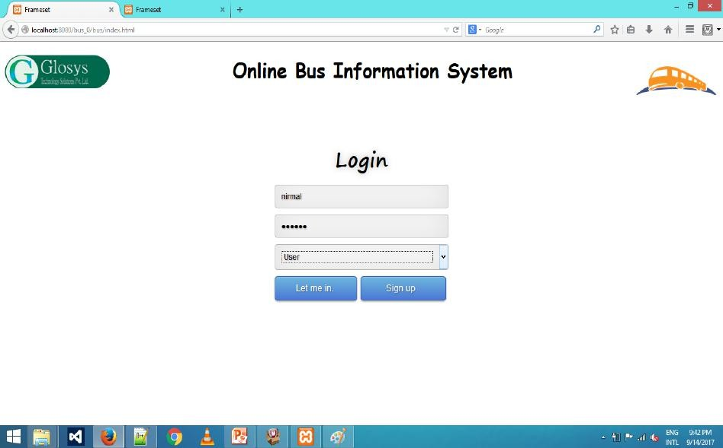

Figure A2.1 Login form

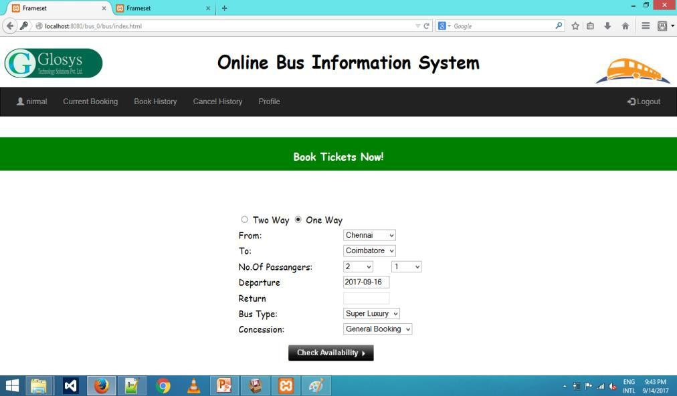

Fig A2.2 Book tickets

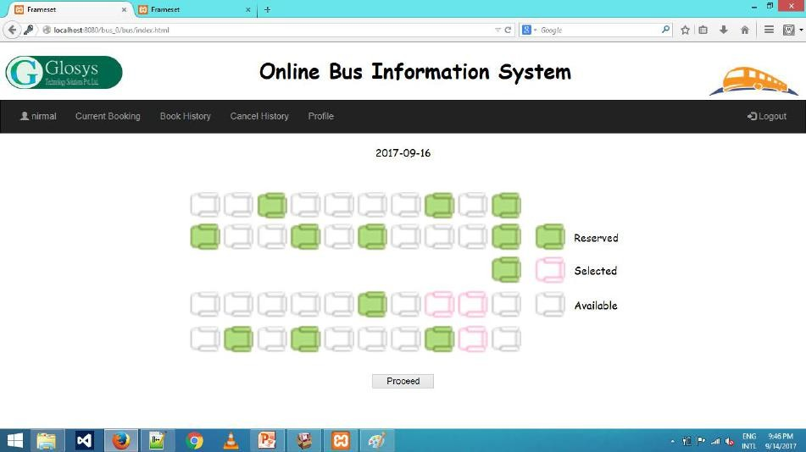

Fig A2.3 Seat layout

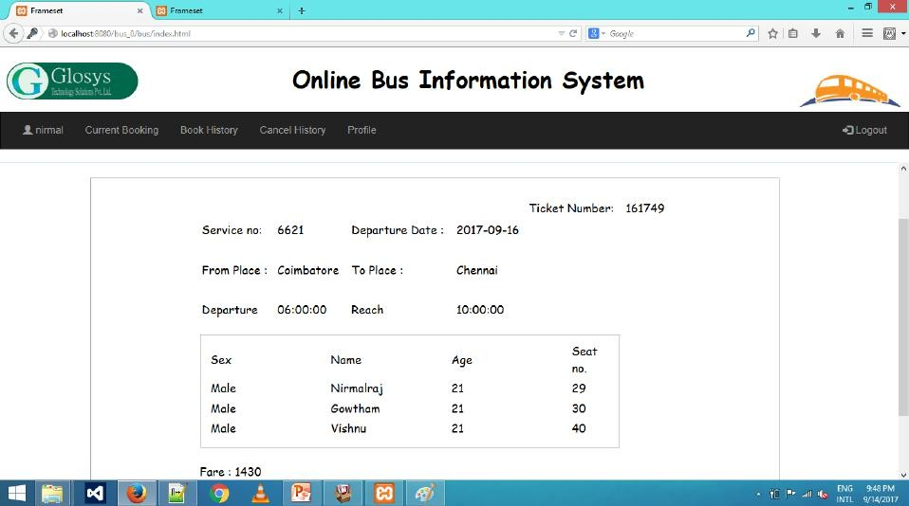

Fig A2.4 Conformation ticket

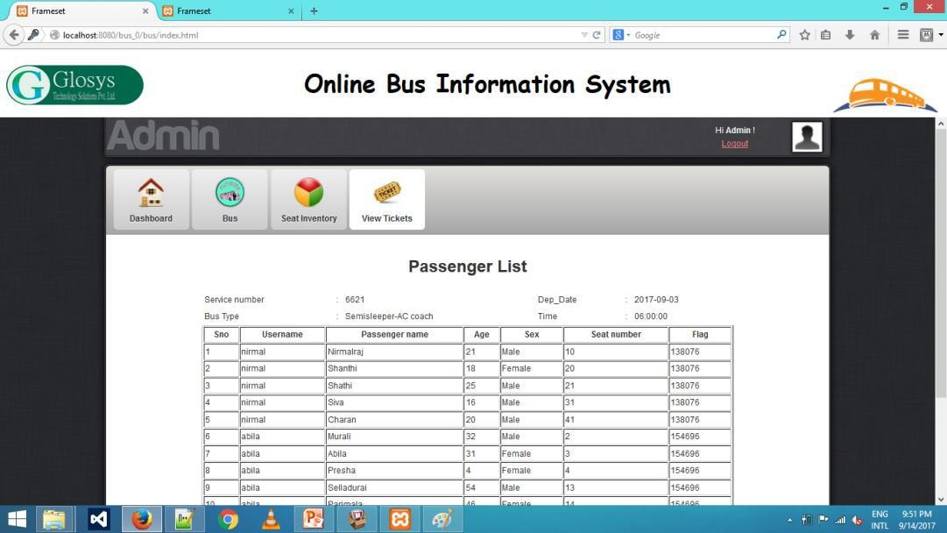

Fig A2.5 Passenger list of particular bus

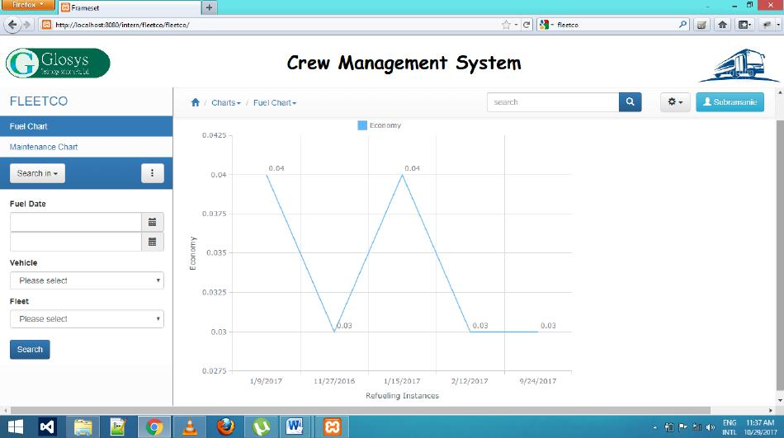

Fig A2.6 Fuel chart record

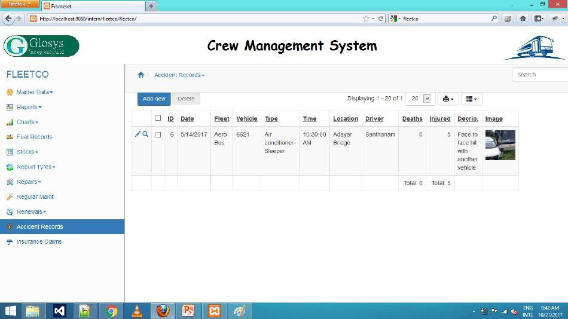

Fig A2.7 Accident record

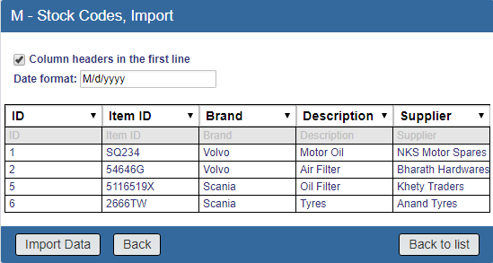

Fig A2.8 Stock Import

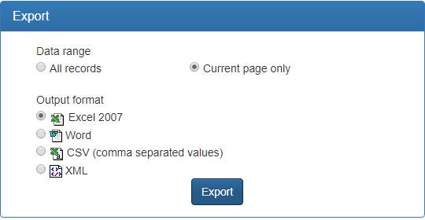

Fig A2.9 Stock Emport

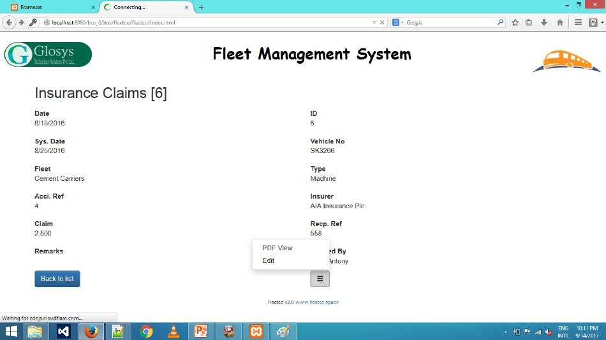

Fig A2.10 Insurance claims view

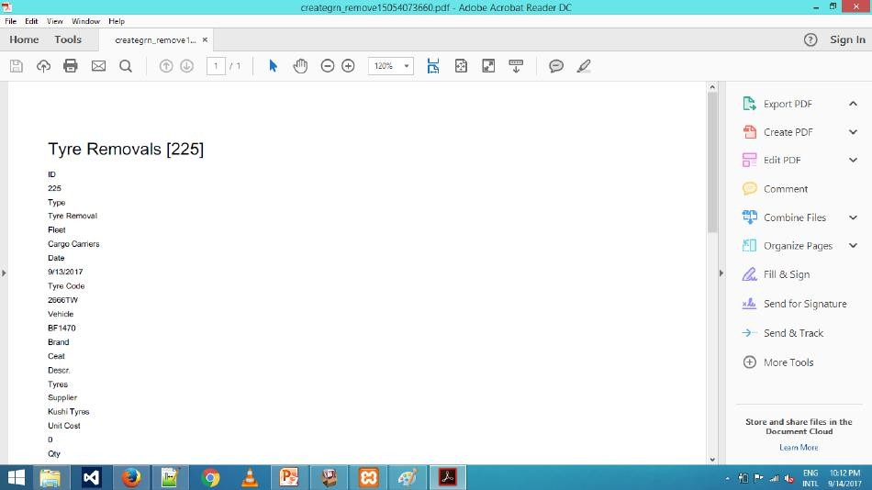

Fig A2.11 Tyre removals pdf

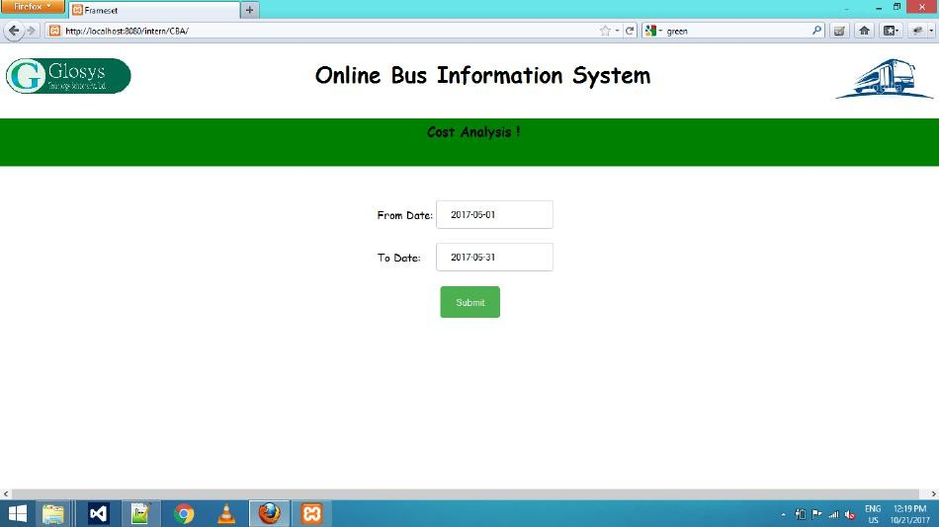

Fig A2.12 Cost analysis record

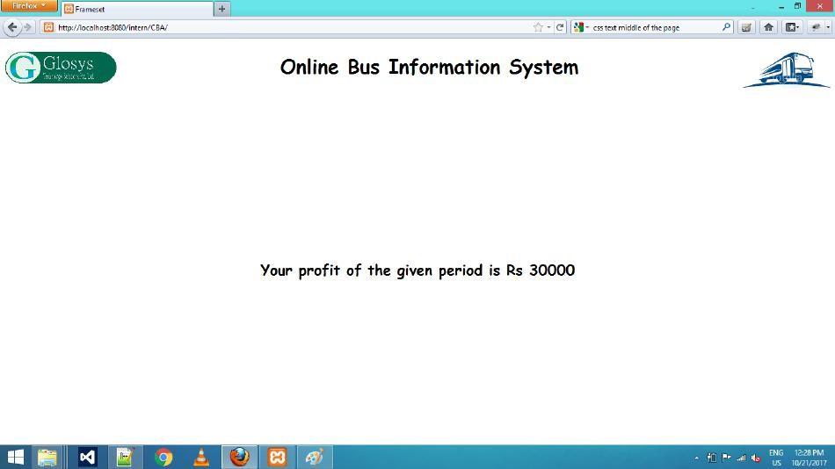

Fig A2.13 cost result record

# REFERENCES

## BOOK REFERENCES

1. Abraham Silberschatz, Henry F Korth and Sudarshan S (2011) ‘Database System Concepts’, Sixth Edition, Mc Graw Hill.
2. Adam Griffiths (2010) ‘CodeIgniter 1.7 Professional Development’ Seventh Edition, Packt publishing, Mumbai.
3. Roger S. Pressman (2014) ‘Software Engineering – A Practitioners Approach’,

Seventh Edition, Tata McGraw Hill Publishing Company, New Delhi.

## WEBSITE REFERENCES

1. <https://www.tutorialspoint.com/codeigniter/>.
2. <https://www.javatpoint.com/what-is-codeigniter>.
3. <http://talkweb.eu/how-to-run-doctrine-orm-with-codeigniter/>